VM-1.1 DAST Scan Report

DRAFT
Control Objective
- Ensure that the company’s people, processes, and technology systems are prepared to perform secure software development
- Protecting all components of the company’s software from tampering and unauthorized access.
- Producing well-secured software with minimal security vulnerabilities in its releases.
- Ensure that all web applications that are DAST-scannable are scanned by an approved DAST scanning tool
  - Ensure that all web applications have full scan coverage of API routes or webpages with an approved DAST scanning tool
Control Validation
- Software applications that have web APIs or webpages must be scanned with the company’s approved DAST scanner before software is released.
  - DAST-scannable applications have full scan coverage of all scannable API routes or webpages
- Software applications that are DAST-scannable must provide a report showing coverage of API routes or webpages with an approved DAST scanning tool before software is released.

Example Metrics
Scan coverage by type and business line
See this link for a live dashboard.
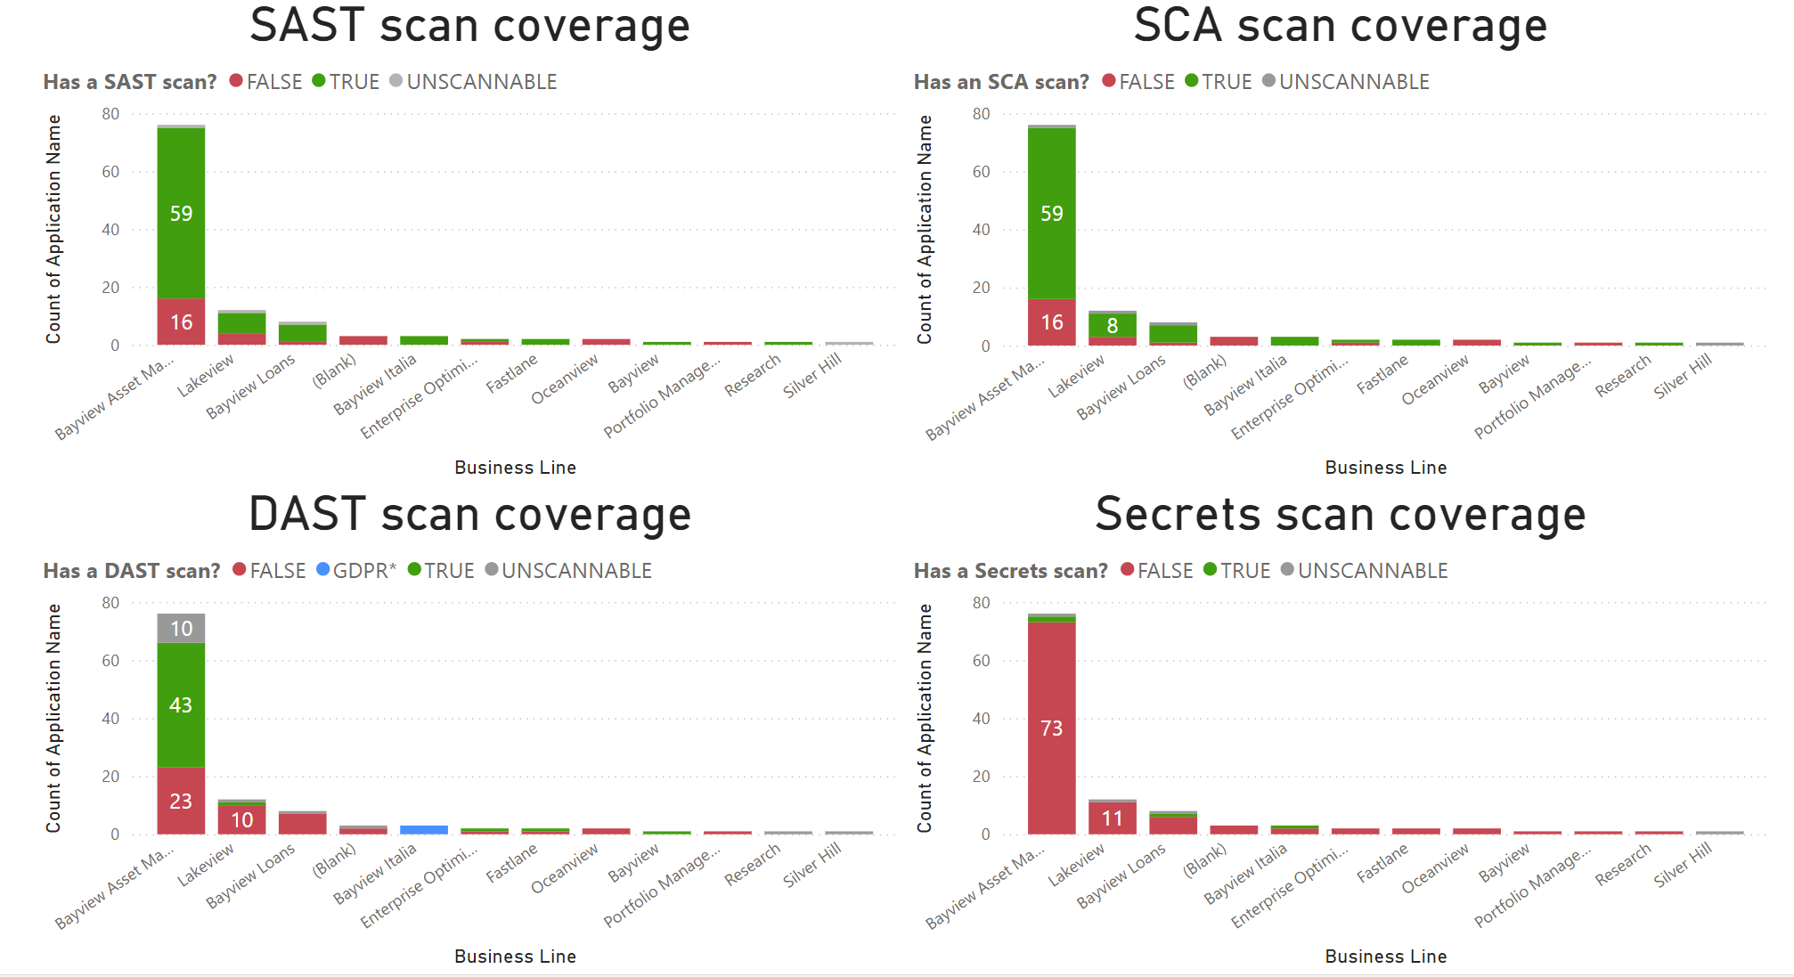
Scan coverage by type and team lead
See this link for a live dashboard.
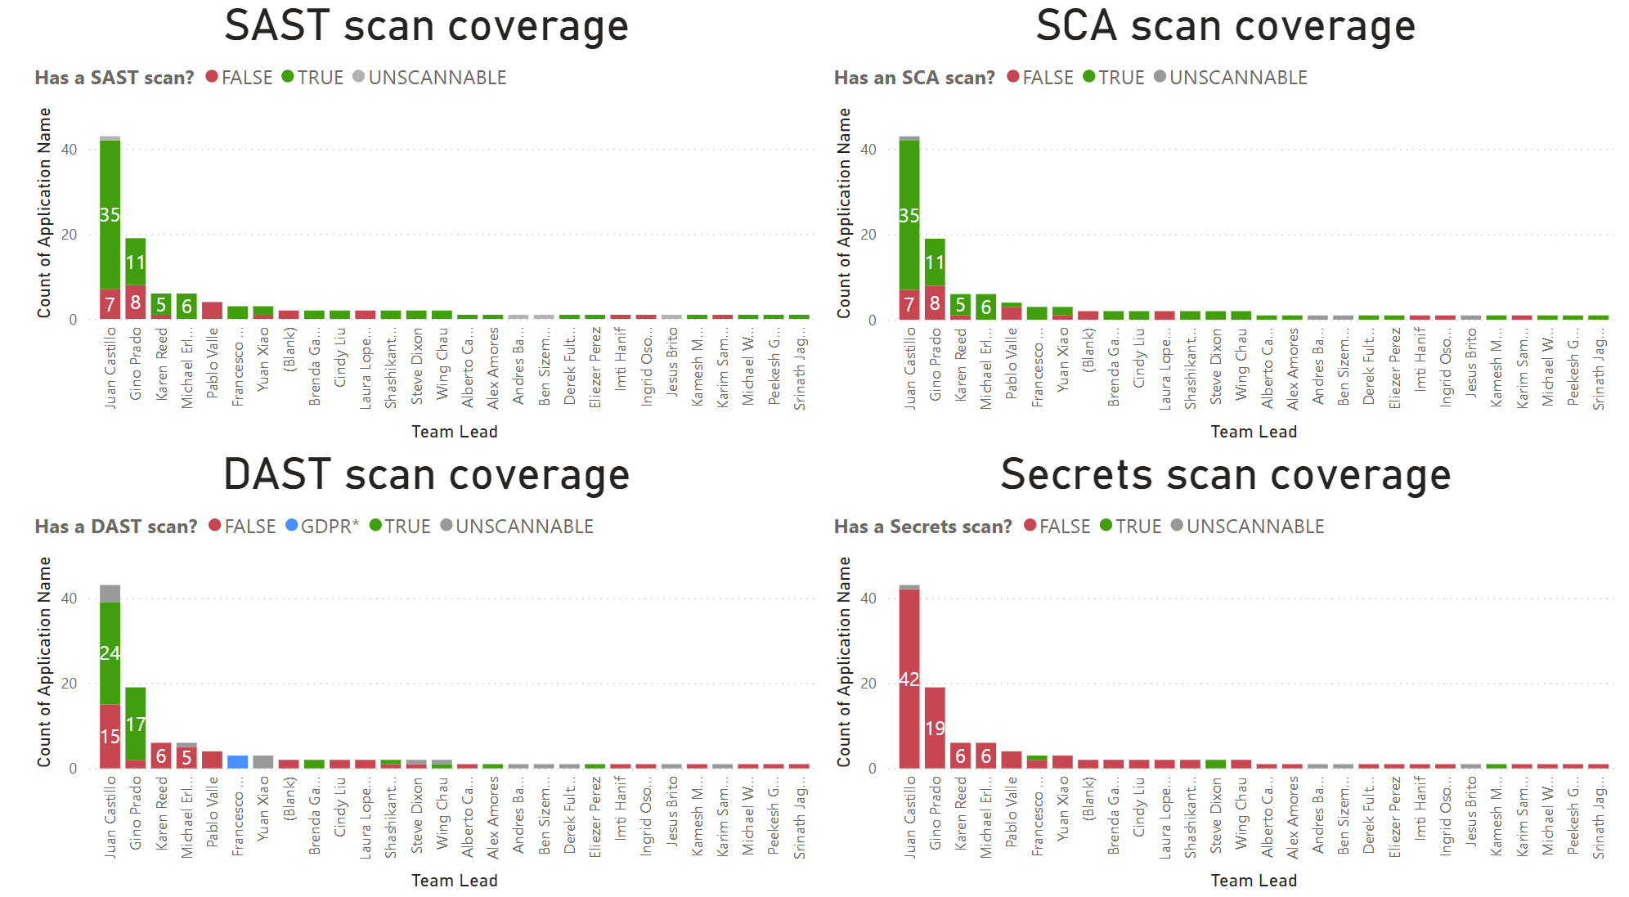
Scan coverage by type, over time
See this link for a live dashboard.
